**UFO Sightings- An Analysis**

**Why we took this approach:**

Bqplot, is helpful in developing interactive visualization using few lines of code. It provides good visualization of data compatible with US State maps. It Provides artistic approach towards visualization with functionality of tooltip and hover. It gives you leverage to interact with large quantity of data.

A few graphs that we came up with,

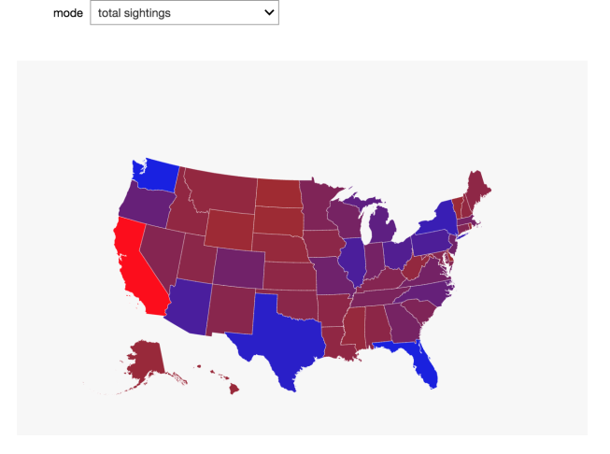 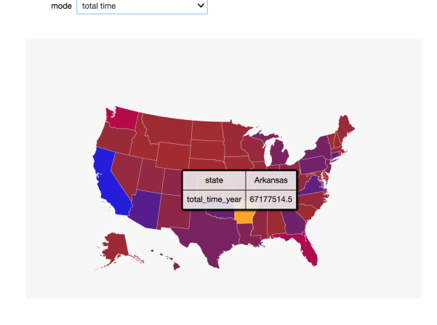

**Strengths of our approach:**

We can make use of many interactive plot under bqplot package, for instance we have used scatter plot which is interactive with US state map along with time slider. It gives more color palettes option for giving aesthetic visualization which soothes human eyes. We can import various functionalities from bqplot such as Albersusa, colorscale, topo_load,map etc which ultimately helped us to obtain desirable interactive visualization.

**Weakness of our approach:**

There are multiple callbacks happening while selecting Total time in sightings from dropdown menu. It was very difficult to select multiple states and plotting the scatter plot related to last selection. There was not enough documentation on bqplot available for all types of interactions.

**What we wished we had been able to do:**

We could have developed faster working visualization as current visualization takes time. Another thing we could have done is we could have looked for corner cases.

**Contribution**:

Coding: Akhil Sreehari and Kashish Kothari contributed towards coding process.

Data Management: Gopikrishnanpr and Sanket Sinha did data management.

Data Cleaning: Akhil Sreehari did Data cleaning.

Infographics: and Presentation: Gopikrishnanpr and Kashish Kothari worked on infographics and presentation

Writeup: Kashish Kothari and Gopikrishnanpr did Writeup.